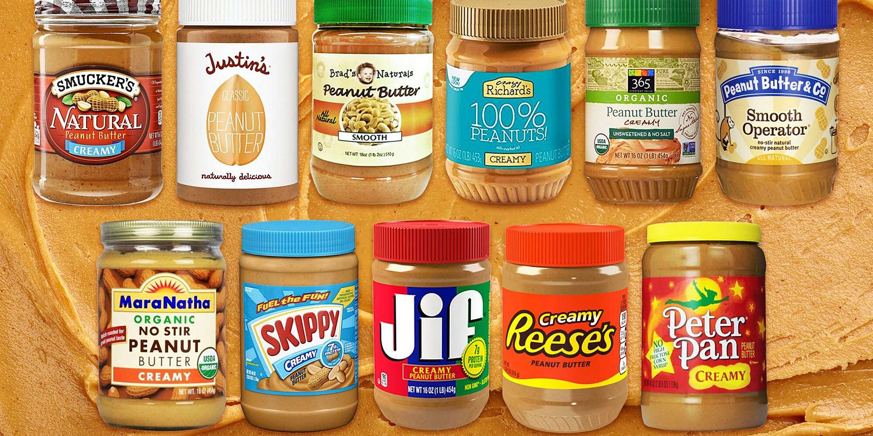
PEANUT BUTTER COLLECTION

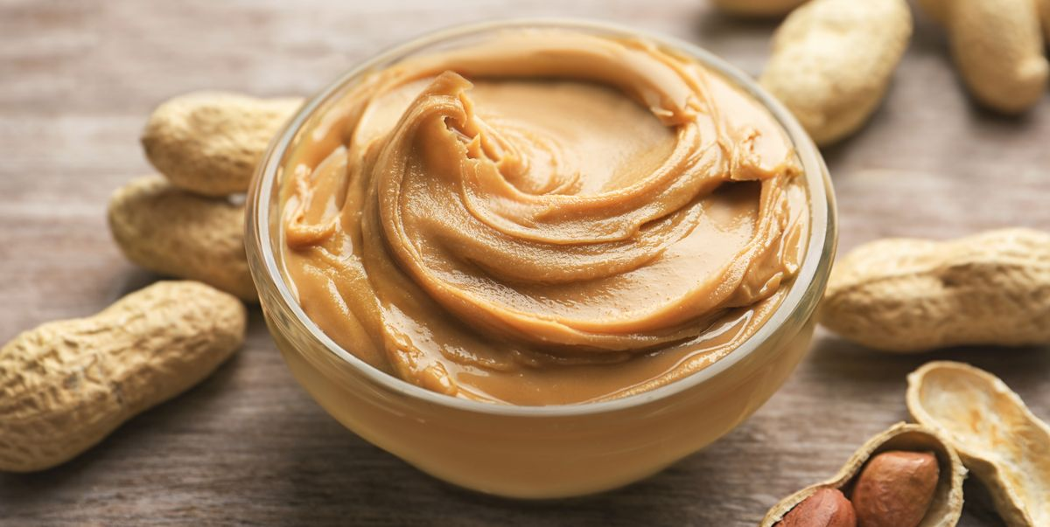
It is time for our annual peanut butter collection!
We accept any type and size of peanut butter: crunchy, creamy, big or small.
Please donate. It is to help the children of the Dominican Republic. Many children need help meeting protein needs and peanut butter is a great source of protein.
Together we can make a big difference in the life of a child!
Jars will be collected from April 4th – May 4th
Do not pass by a man in need. For you may be the hand of God to him. Proverbs 3:27

